Technology Enabled-Learning (Week-4 Assignment) TEL Activity Plan

Name: Md. Enamul Haque
Grade / Course: Grade 10 ICT
Length of Activity: 50 minutes

Lesson Summary:
Students will identify the different storage devices that forms part of a computer memory system and draw a table to list the different storage devices. Students will know about primary, secondary internal & external memory or storage devices.

Lesson Objective:
Students should be able to differentiate between computer memory and storage devices and identify examples of storage devices.
.

Resources/Technology – Teacher
Projector
Online Resource
- http://www.teach-ict.com/gcse_new/computer%20systems/storage devices/miniweb/index.htm
- https://www.slideshare.net/khalidkhayam/computer-hardware-and-its-components
- http://www.teach-ict.com/gcse_new/computer%20systems/storage_devices/miniweb/index.htm

Resources/Technology – Students
Computer Lab, access to the internet
Worksheet /Learning Materials
Online Resources
- http://www.uh.edu/engines/epi2320extras.htm
- http://www.teach-ict.com/gcse_new/computer%20systems/storage devices/quiz/ontarget_input.htm
- https://k8schoollessons.com/computer-input-and-output-devices-quiz-1
- http://www.uh.edu/engines/epi2320extras.htm

Intended Curriculum Learning Outcomes
- Students will able to know about (memory) storage devices
- Students will be able to identify different types of stores devices of a computer
- Students will be able to use the different storage devices.

Instructional Activities
The teacher will explain and discuss in class the different storage devices and present a small powerpoint on various storage devices.
The teacher will form small groups of 2 to 3 students and give instructions to complete a worksheet containing a table to list the storage devices, thos are the different parts of a computer system.
The teacher will also provide instructions on how to complete the quiz questions on different web links(25 minutes)

Students are given time to complete the worksheet and online quizzes. (25 minutes)

Learner Assessment
Students will identify the different storage devices that make up a computer system and also complete the table to list the different storage devices they have learnt.

NAME: ...................................................................................... DATE: ........................

SOME STORAGE DEVICES

Question 1 : Identify different storage devices

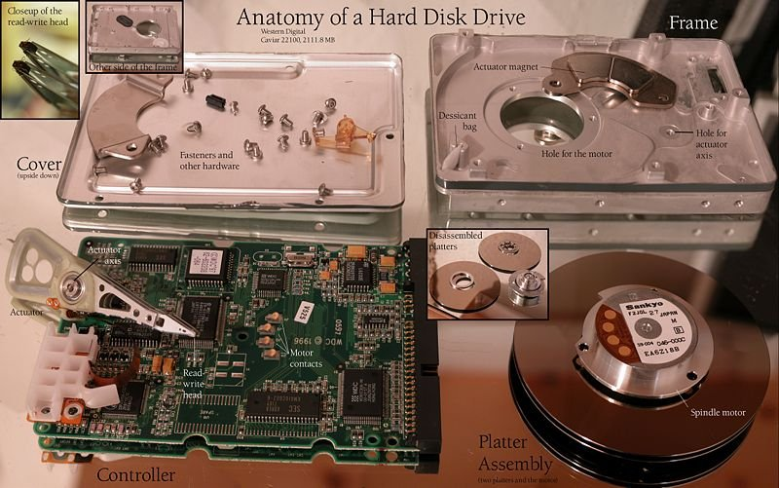

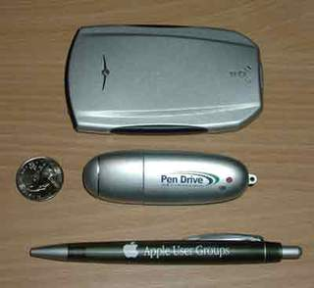

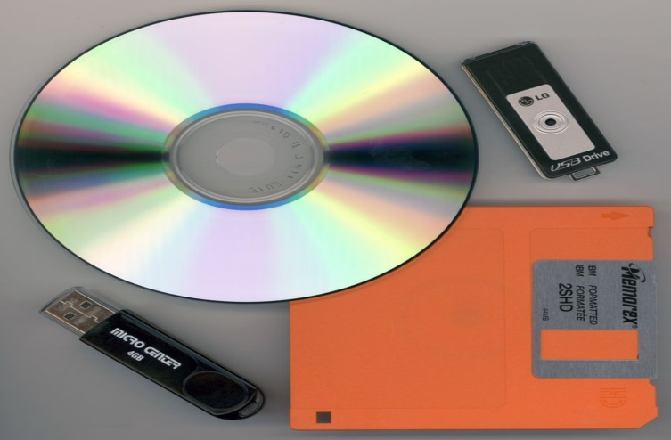
Some external information storage devices familiar to computer users.

Question 2 : List down 5 storage devices

Storage devices
2.
3.
4.
5.

